Riverside Surgery Newsletter
February 2018
Surgery Opening times
 | Open | Lunch | Closed
Monday | 8.00am | 1.00 – 2.00pm | 6.00pm
Tuesday | 8.00am | 1.00 – 2.00pm | 6.00pm
Wednesday | 8.00am | 1.00 – 2.00pm | 6.00pm
Thursday | 8.00am | 1.00 – 2.00pm | 6.00pm
Friday | 8.00am | 1.00 – 2.00pm | 6.00pm
The practice is open on a Wednesday morning between 07.00am and 9.00am for pre-booked appointments only; these will be with the Nurse Practitioner.
The surgery will be closed on the afternoon of Tuesday 20th February for Protected Learning time.

Missed Appointments!

We would like to thank all the patients that have contacted us to cancel their appointments as in the last two months we have seen the DNA percentage drop by 50%.

During January there were twenty one missed appointments which has cost the NHS £474.60

National Diabetes Audit

Your diabetes service is taking part in the National Diabetes Audit (NDA). The NDA checks whether people with Diabetes are getting good care.
They will collect information about diabetes care from GP Practices and Hospitals, this information will help the NHS improve care. The NDA information is controlled by law and strict rules of confidentiality. Please ask for a leaflet from reception.

OCD Week of Action!
19th – 25th February

OCD WOA is aimed at anyone affected by OCD (including family and friends!) or anyone who has interest in campaigning to make a difference for people with OCD. We may be in 2018, but mental health stigma is still rife, and this needs to change. If you or anyone you know is suffering with OCD then please go to the website www.ocduk.org where you can find a wide range of information on OCD including an advice line and community support forum.
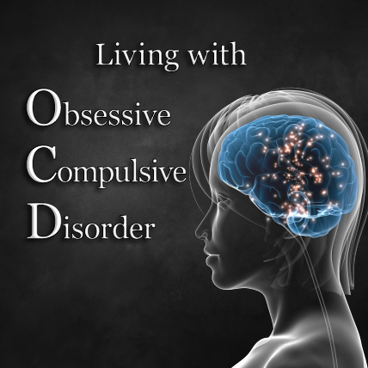

Eating Disorder Awareness Week
26th February to 4th March

Eating disorders can have a devastating impact on the lives of sufferers and the people around them.

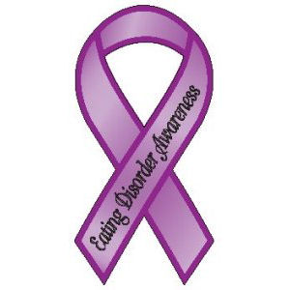

Eating Disorders Awareness Week is an international awareness week that focuses on issues that matter to people affected by eating disorders. Past awareness weeks have focused on self-esteem, eating disorders in the workplace, and the importance of good understanding of eating disorders. The aim is to raise awareness of eating disorders and encourage understanding and compassion towards those affected. The following website has information on the different types of eating disorders, spotting the early signs and can signpost you to support services.
www.beateatingdisorders.org.uk

The combination of cold weather and loneliness could be lethal during the winter.
Simple acts of companionship" could make all the difference. This could include visiting elderly friends, family and neighbours more regularly, doing the shopping for them or picking up prescription medicines. The issue is being highlighted as part of the NHS Stay Well this Winter campaign.
It comes amid growing evidence of the impact of loneliness; It has a devastating and life threatening impact on all ages.

