One Health and Care – IS GOING LIVE IN AUGUST
‘One Health and Care’ is a new integrated care record for individuals registered at Staffordshire and Stoke-on-Trent GP practices that brings data together from the different organisations involved in health and social care.
Completely confidential and secure, it’s designed to help doctors, nurses and other registered health and social care professionals directly involved in your care to make better, safer decisions.
The information that they will be able to see includes:
- Your name, date of birth, sex, address, telephone number, NHS number
- The name of your GP Practice and GP
- Medications, allergies, ongoing and historic conditions, immunisations and diagnoses
- Test results, hospital referrals, admissions, discharges and clinics attended
- Social and mental health information and care plans
Sensitive information such as attendance at sexual health clinics, fertility treatment records, and records relating to gender reassignment will not be included.
One Health and Care is available for access by health and social care organisations within Staffordshire and Stoke-on-Trent, and data that will be available is as follows:

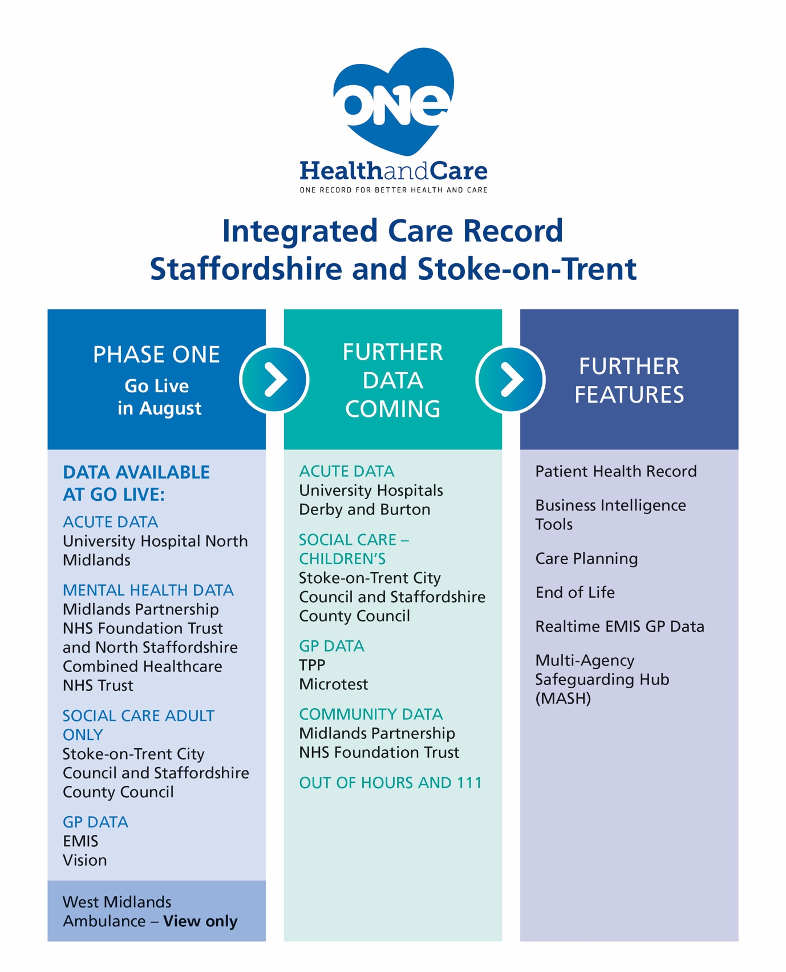
For more information, contact:
W: onehealthandcare@nhs.net
E: onehealthandcare@nhs.net
T: 0800 030 4563 (Patient Advice and Liaison Service)

