Riverside Surgery Newsletter
July 2018

Protected Learning Time  The surgery will be closed on the afternoon of Tuesday 17th July from 1.00pm.  We are sorry for any inconvenience caused. | Confidentiality  To avoid any ill feeling,  if you would like us to be able to speak to a designated third party on your behalf regarding your medical information including confirming appointments could you please ask for the consent form at Reception, unfortunately unless we have your consent in writing we will not be able to discuss your information with anyone else.

Stay safe in the sun!

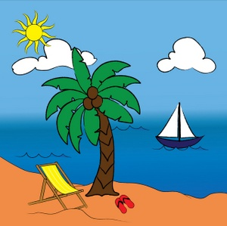

The best way to enjoy the sun safely and protect your skin from sunburn is with a combination of shade, clothing and sunscreen.

When the sun is at its strongest (between 11.00am and 3.00pm in the Uk) spend time in the shade and cover up with clothes, a hat and sun screen.

Aways use a sunscreen with a protection level of at least SPF15 and 4 stars. Make sure you reapply especially after going in water even if your sunscreen is water resistant.

Contact Details!

Could all patients please ensure that we have the correct contact details please, especially mobile numbers. Give the surgery a call or you can register for online services where you can change your personal details, order prescriptions and book appointments. Ask at reception for the details.

Travel Vaccines  You can have your travel vaccines here at the surgery. Please book an appointment with the Nurse Practitioner to discuss your requirements.  Please book in at least six weeks before you are due to travel, we are unable to offer the Yellow Fever vaccination in surgery. | Summer safety  - Are you drinking enough in the hot weather? Make sure you drink plenty, even if you aren’t thirsty!  - Never leave children or pets alone in the car!  - Check on any elderly or vulnerable neighbours or family members.  - Use a damp flannel or towel to cool yourself down if you feel you are getting too hot  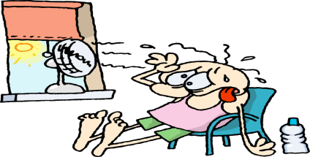

Surgery Opening times
 | Open | Lunch | Closed
Monday | 8.00am | 1.00 – 2.00pm | 6.00pm
Tuesday | 8.00am | 1.00 – 2.00pm | 6.00pm
Wednesday | 8.00am | 1.00 – 2.00pm | 6.00pm
Thursday | 8.00am | 1.00 – 2.00pm | 6.00pm
Friday | 8.00am | 1.00 – 2.00pm | 6.00pm

